# **Repetition as a Principle of Design**

## **What is the Repetition Principle of Design?**

**The repetition principle of design** means that the same or similar elements are used again. The principle of repetition in design is used to achieve consistency and uniqueness.

The principle of design repetition simply means that pictorial elements are completely or partially reused. These can be the same or similar colors in the design, the use of the same or similar lines, fonts, sizes, and textures, or certain shapes of elements.

The repetition of the design can happen regularly, it can be even or uneven, regular or irregular.

Based on Oxford Languages, the principle of repetition is most simply explained as the repetition of actions, things, certain events, or elements in one design. However, the principle of design repetition is not limited to only one work of art but can happen to a whole collection of works of art.

There are seven basic design principles:

* Emphasis (focus on the design and order of importance of each of its elements)
* Balance and Alignment (refers to a well-organized [balance between elements in design](https://study.com/learn/lesson/radial-balance-design.html))
* Repetition (repetition of [design elements](https://study.com/learn/lesson/mass-elements-design-manipulation-influences-examples.html))
* Movement (refers to an element of control to move in the right direction to properly inform the target audience)
* Contrast (refers to the creation of difference and space between elements when designing)
* Proportion (visual weight or size of elements, which serves to approach the design in parts)
* White Space (white space around elements that indicate their organized grouping)

All the mentioned elements can be noticed very easily, whether it is their absence or appearance, however, repetition is a characteristic principle in design that cannot be noticed so easily. Elements, colors, images or lines can be organized so well that it is almost impossible to always notice them.

During the repetition, there should be a limit to how many different patterns should appear. Too many different forms can have a bad effect on the usability and quality of the design itself. That is why it is recommended to use up to 3 different patterns during the repetition.

## **Principles of Design Repetition**

There are **three main principles of repetition**:

* Aesthetics
* Consistency
* Usability

Aesthetics represent the perception of certain elements in the design based on what is presented in it. Based on aesthetics, people create thoughts, perceptions, and feelings about a certain design, which further affects their satisfaction with the design itself. In short, aesthetics in design affect people's attitudes about a certain product.

Consistency is a key principle in design, and it is often violated. Consistency in design means equalizing the elements so that they look the same, that is, "uniformized" so that the element is usable and always enables easy availability of the product.

Usability refers to the quality of use of the product, it refers to the ease of use of a certain design. Usability is a very important principle because it affects success during design. If the usability is bad, the design itself can be bad and the final product can be doomed to failure in advance.

Repetition in design can be a very fun and desirable process if used correctly. There are three methods of repetition, namely repetition, patterns, and rhythm. Different shapes, lines, or colors can be repeated in the right way using these three methods. For example, a designer can draw one vertical line and draw several others next to it. By repeating the same colors, shapes, or lines in the right way, consistency is achieved with the user, as repetition can be used for reinforcement.

Patterns can be seen, for example, on carpets. Different shapes and colors often intertwine and reappear, whether they touch or have a gap between them.

Given that people remember colors, shapes, or textures better than numbers, designers very often experiment by repeating the same or similar colors or shapes, which also affects the better aesthetics of a certain design. Rhythm is one of the methods of repetition used to create space between elements and to create a feeling of rhythm or movement in the user. The use of rhythm can be random, regular, more than one element can be repeated ([alternating rhythm](https://study.com/learn/lesson/rhythm-art-types-examples-progressive-alternating-regular.html)), flowing rhythm or progressive rhythm can be used.

All these methods are used to visually present the product to the user, and the correct use of certain elements (such as colors, lines, textures, or shapes) helps in this.

## **How to Use Repetition in Art and Graphic Design**

**Graphic design** is completely different from classical art because, unlike art that can provide freedom in designing, graphic design has set standards, guidelines, and rules for solving [communication problems](https://study.com/learn/lesson/communication-problems-causes-examples-issues.html), so that the final product is as efficient as possible for users. To come up with a more efficient design, graphic designers use principles such as balance, proximity, contrast, [alignment](https://study.com/learn/lesson/alignment-principles-types-graphic-design.html), [hierarchy](https://study.com/learn/lesson/hierarchy-in-design-principle-examples.html), and repetition. The main purpose of repetition in graphic design is to create consistency.

As with overall design, repetition in graphic design can be used in colors, fonts, size, or texture. Repetition in graphic design serves to inspire graphic designers in communication with users.

By repeating the same colors, shapes, or sizes of a certain design, its completeness is achieved, i.e. the cohesive whole of the design and making the design easily recognizable. For better efficiency and usability of the design, it is recommended to combine the repetition of the same shapes, colors, and lines.

Repetition in **art** is very frequent and one of the most interesting phenomena, which is considered the basis of creativity. Repetition in art is used to deviate from traditional art and to present and create a certain portrait, design, or intrigue the audience in an interesting way. Repetition in art also aims to present the work of art aesthetically, redefining the original and the copy or focusing on what the work of art makes visible. Repetition in art is reflected in the repetition of certain lines, shapes, and other visual elements that are intentionally visible or invisible to the audience. Artists use repetition to warn the public about current issues, as well as increase the sense of tension.

Repetition is art that can be regular or irregular, and even or uneven. Often, repetition in art has a very deep meaning that sends a certain message to the audience.

Repetition in business logos represents the use of the same or similar elements (color, line, shape). It aims to make the logo consistent, and, it is very important to be careful with repetition so as not to create the opposite effect. Repetition affects aesthetics (improves the appearance of the logo), cohesiveness (affects customer loyalty and encourages sales), and brand unity (makes it easier for consumers to recognize the brand or product) and can make the logo more balanced, attractive, and recognizable through the use of the same or similar shapes, colors, font, and movement.

Repetition is also used for consistent layouts on web pages. Namely, designers use the repetition of the same or similar elements to help their users find specific content on the site more easily and to enable reliable surfing on a specific website. Repetition for the sake of consistent layout on webpages aims to coherently organize information on the site, clearly guide users around the website, provide the necessary information to users in the best way, enable them to predict how things work, and aim to provide people with a pleasant experience on a certain website. In this sense, repetition refers to graphics, colors, photos, navigation, links, or logos.

## **Examples of Repetition in Design**

The best example of repetition in design is reflected in the branding. In every well-known and high-quality brand, you can see the repetition of certain colors, fonts, motifs, lines, or shapes. A perfect [example of graphic design](https://study.com/learn/lesson/what-is-graphic-design.html) is the Google logo, which is used by repeating the same colors that are characteristic and recognizable on its other logos.

An example of repetition in design can be seen in the following picture:

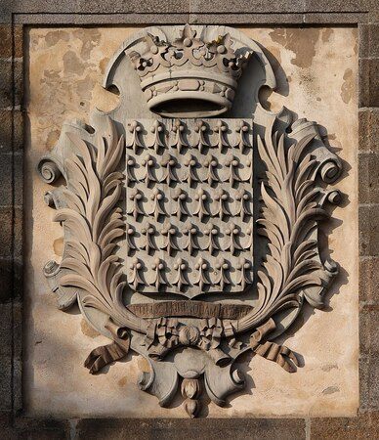

***Saint-Malo-armes de Bretagne***

As for repetition in art, repetition can be seen in world-famous artists such as Claude Monet, Andy Warhol, and Yayoi Kusama.

Repetition in Claude Monet can be seen in many paintings with at least two ships. He experimented with repetition in nature.

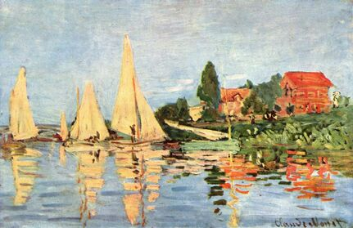

***Claude Monet***

Andy Warhol was known for repeating the same or similar colors and other elements such as portraits of people. Warhol was an advertising illustrator who used the same techniques in his illustrations.

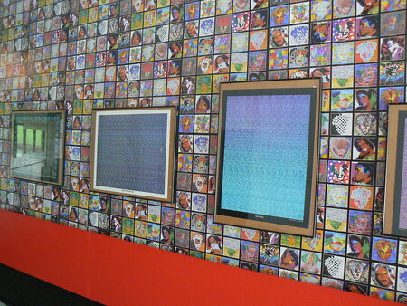

***Andy Warhold Museum***

Yayoi Kusama is a Japanese artist and writer. Her art is based on prominent psychedelic colors, repetitions, and matrices. Kusama is considered to have been the inspiration for many of Warhol's works.

***Yayoi Kusama***